Friedhelm Loh Group supports charitable organisations
Owner and employees of the Friedhelm Loh Group donate 200,000 euros for social facilities and relief organisations
Herborn, 12 May 2025
Nothing exemplifies a sense of community better than the willingness to help others – especially in economically difficult times, when the readiness to donate money normally tends to decrease. The traditional employees’ annual charity drive of the Friedhelm Loh Group shows that this doesn’t have to be the case. Especially now, the employees and owner Prof. Friedhelm Loh have a thought for the weakest members of society – and have acted accordingly. Together, they have collected 200,000 euros for distribution to 13 charitable organisations and international relief organisations. The list of recipients ranges from local Tafel food banks to the Christian Hospice Service in Görlitz and the Spanish Red Cross.
Direct and unbureaucratic assistance to relieve suffering and give fresh heart – that is the motivation behind the annual donation campaign, for which Prof. Loh topped up the sum raised by the employees to an impressive total of 200,000 euros. “Thank you for all your donations and for the active charity this demonstrates,” said Prof. Friedhelm Loh in a message to donors from all over the company group. “There are so many people both around the world and in our local region who need our help to secure a liveable future.”

The amount donated is being shared across a total of 13 charitable facilities and welfare organisations in the regions around company locations and at international level: Help Ukraine Breitscheid, Debora Foundation India, Hephata Diakonie Schwalmstadt-Treysa, Jumpers Gera, Evangelical Integrative Day Care Centre Monheim, Caritas Workshops Montabaur, Görlitz Christian Hospice Service, Diakonisches Werk Dillenburg-Herborn, Lebenshilfe Altenkirchen, Oberlausitzer Kinderhilfe Bautzen, Tafel Hessen food banks, Spanish Red Cross and Evenzkreis Mühlacker/Wiernsheim. All donations are channelled to the individual recipients quickly and unbureaucratically via the Rittal Foundation, the charitable foundation of the Friedhelm Loh Group.

Huge effort for food and social participation
The example of Tafel Hessen, the association overseeing a network of regional food banks, illustrates just how important this financial assistance can be. It has been able to rely on the support of the Friedhelm Loh Group ever since its founding in 2016 – and that was also the case in 2024: 20,000 euros were allocated from the annual employee donations, and a similar sum was provided by the Rittal Foundation. Around 5,800 predominantly volunteer helpers ensure that close to 110,000 people in need in the state of Hesse are able to pick up a bag of groceries once a week, or else facilitate their social inclusion by offering a cup of coffee and a piece of cake. Everything radiates from the organisation’s central warehouse in Wetzlar: From here, consignments of food products, toiletries and other everyday necessities are sent out to local food banks all over Hesse for distribution to the entitled beneficiaries. Without donations, this huge organisational and logistical effort would be impossible.

The gift of happy times spent together
The same can be said of the important work done by the Christian Hospice Service in Görlitz. There, volunteers provide care and support to terminally ill patients of all ages – and their families – in their own home surroundings, in residential and nursing homes and in hospitals. Once a year, the child and youth hospice service organises a family weekend for those in its care. It is only through donations that this opportunity for a few carefree hours together can actually take place – with a colourful range of activities for the children and their parents. For the families, the weekend is a short but valuable break from the challenges of their everyday life.

Reconstruction in the disaster zone
Following last year’s catastrophic floods in Spain, the Red Cross managed an initial phase of untiring emergency relief to provide immediate assistance to those affected. A sum of 30,000 euros from the employee donations was designated for immediate aid in connection with the flood disaster. One of the most important tasks to date has been to distribute critical supplies of food, water and medical kits, alongside the establishing of emergency accommodation and offers of psychological support for the local people. Looking ahead, the next phase is a three-year programme of reconstruction. This long-term strategy will be concentrated on reconstruction of the affected villages, restoration of a basis for sustainable livelihoods in the region and further on-going assistance for the most vulnerable sections of the population. In this way, the Spanish Red Cross hopes to ensure that everyone receives the care and attention they deserve throughout the strenuous reconstruction process.

Responsibility for our surroundings
Tackling need by working together – in our home region, at company locations and abroad – has been a matter close to the heart of Rittal, the family-run business, ever since its founding in 1961. When Rittal celebrated its 50th anniversary in 2011, owner Professor Loh established the Rittal Foundation, which officially began funding in 2012. In the meantime, the Rittal Foundation and the Friedhelm Loh Group – with employees and management representatives operating hand in hand – have raised more than eight million euros to support good causes.

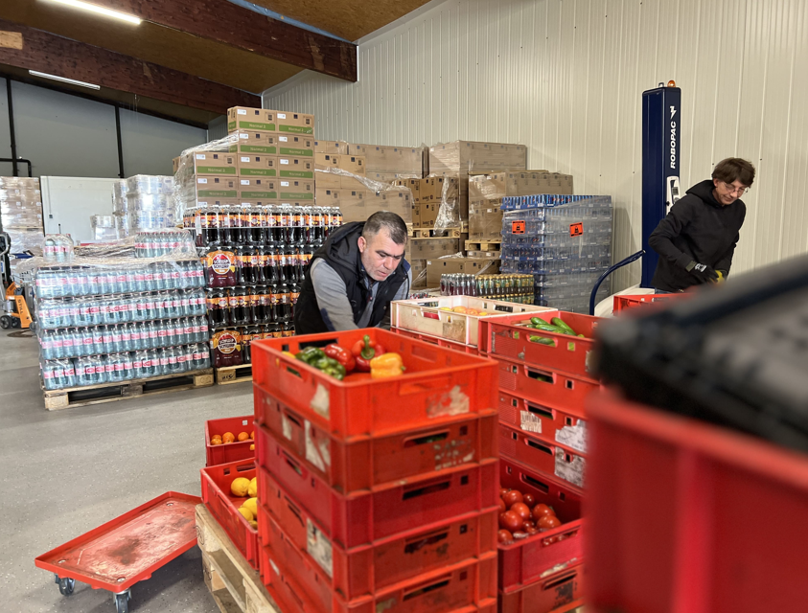 |  | 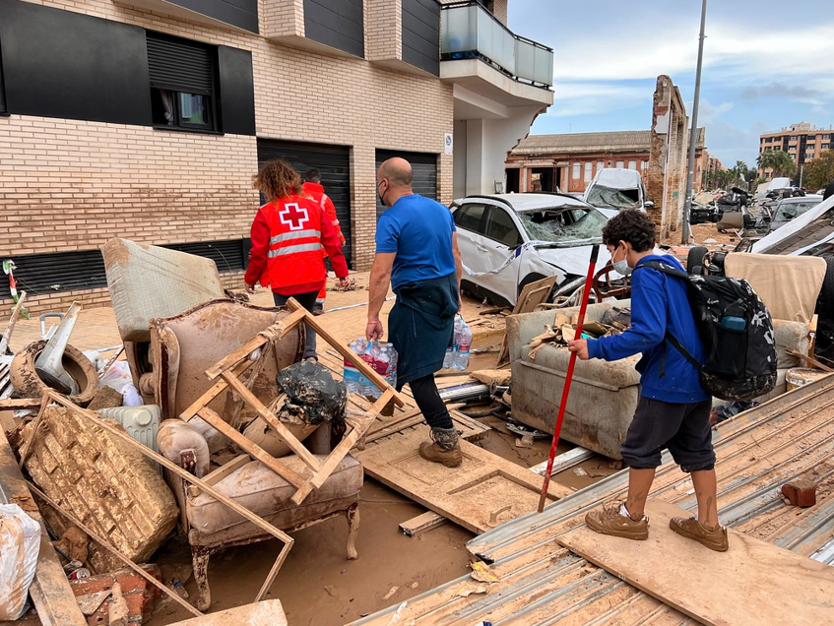
Caption  The central warehouse of Tafel Hessen in Wetzlar sends consignments of food products, toiletries and other everyday necessities to local food banks all over Hesse for distribution to the entitled beneficiaries. |  | Caption  Following last year’s catastrophic floods in Spain, the Red Cross managed an initial phase of untiring emergency relief to provide immediate assistance to those affected.

May be reproduced free of charge. Please name the Friedhelm Loh Group as source.

Friedhelm Loh Group

The companies of the globally successful Friedhelm Loh Group invent, develop and produce innovative system solutions for industry, IT and energy, as well as other important sectors worldwide. They are among the top addresses in their respective industries.
With their combined hardware and software expertise, Rittal, Rittal Software Systems (Eplan and Cideon) and Rittal Automation Systems (RAS, Ehrt, Alfra) optimize, digitize and automate processes along the entire customer value chain, including the IT infrastructure – from panel building and switchgear manufacturing to mechanical engineering, factory operators and the energy sector. Stahlo and LKH round off the portfolio with end-to-end manufacturing expertise in the modern materials of steel and plastic.
The Group is internationally successful, with 13 production sites and 95 subsidiaries. The family-owned company employs 12,600 people and generated a turnover of 3.1 billion euros in 2023. In 2023, the Friedhelm Loh Group was recognized as a “Best Place to Learn” and “Employer of the Future.
For more information, visit www.friedhelm-loh-group.com.

Corporate Communications
Dr. Carola Hilbrand Friedhelm Loh Group
Corporate & Brand Communications Rudolf-Loh-Straße 1
Phone: 02772/505-2527 35708 Haiger
hilbrand.c@rittal.de www.friedhelm-loh-group.com

